Car Rental Management System: Analysis and Design Document
System analysis and design with AzamPay (Azam Pesa) payment gateway integration

1. Introduction

1.1 Purpose
This document describes the analysis and design of a Car Rental Management System (CRMS). It covers actors, use cases, data flow diagrams (Level 0, 1 and 2), the entity relationship diagram, state models, the payment integration and the database schema.

1.2 Scope
The CRMS lets customers search, book, pay for and rate vehicle rentals, and lets staff manage fleet, pickups, returns, maintenance, fines, invoices and reports across multiple branches. All electronic payments (mobile money, bank and card) are processed by an external payment gateway, AzamPay (Azam Pesa). The CRMS never stores card numbers, PINs or mobile money credentials. It stores only the gateway reference, status and amount.

1.3 Assumptions
- Currency is Tanzanian Shillings (TZS). Tax (VAT) is configurable.
- Customers pay by mobile money push (USSD prompt on the phone), bank or card via AzamPay. Cash at the counter is optional and recorded manually by an agent.
- Gateway results arrive asynchronously through a callback (webhook), so the system must confirm payments by callback and by status query, not only by the initial API response.
- The exact AzamPay endpoints, authentication and callback payload must be confirmed against AzamPay's current developer documentation during implementation.

2. Actors (User Types)
Actor | Type | Responsibilities
Customer | Primary, human | Register, verify documents, search, book, pay, modify or cancel, view history and fines, rate
Counter Agent | Primary, human | Walk-in bookings, document check, pickup and return, inspection, extension, cash payments
Branch Manager | Primary, human | Fleet and staff of one branch, approve discounts and damage charges, branch reports
Fleet/Maintenance Staff | Primary, human | Service scheduling, cleaning, damage and repair logs, document expiry tracking
Finance/Accountant | Primary, human | Invoices, refunds, deposit settlement, reconciliation with gateway, fines billing, tax reports
Admin | Primary, human | Branches, categories, rates, extras, insurance, promos, users, roles, audit logs
AzamPay Gateway | External system | Processes payments and refunds, sends callbacks
SMS/Email Service | External system | Delivers notifications and reminders
Scheduler (System) | Internal, automated | Expires holds, sends reminders, flags overdue rentals, reconciles pending payments
Driver (Chauffeur) | Primary, human | Office staff who drive customers who ask for a driver; logs daily trips, reports incidents and fines, sets availability

3. Functional Requirements
ID | Requirement
FR1 | Register, authenticate and manage roles and permissions
FR2 | Verify customer ID and driving license; support blacklisting
FR3 | Search availability by branch, dates and category
FR4 | Compute price: base rate, extras, insurance, promo, tax, deposit
FR5 | Create, modify, cancel and extend reservations
FR6 | Initiate payments through AzamPay and confirm them from callbacks
FR7 | Record pickup and return with odometer, fuel and photos
FR8 | Compute late, fuel, mileage and damage fees
FR9 | Generate invoices; process refunds and deposit release through AzamPay
FR10 | Record traffic fines and tolls and bill them to customers
FR11 | Track maintenance, insurance and registration expiry
FR12 | Send notifications (confirmation, reminders, overdue)
FR13 | Produce utilization, revenue, tax and overdue reports
FR14 | Keep an audit log of sensitive actions
FR15 | Offer an optional office driver at booking; price it, assign a driver and track daily trips
FR16 | Check traffic fines at return inspection and assign each a liability: customer or company
FR17 | Bill only customer-liable fines; absorb company-liable fines and log them against the vehicle or driver

4. Use Case Model

4.1 Use case diagram
The use case diagram below shows each actor and the use cases it takes part in. Use cases are grouped by subsystem.
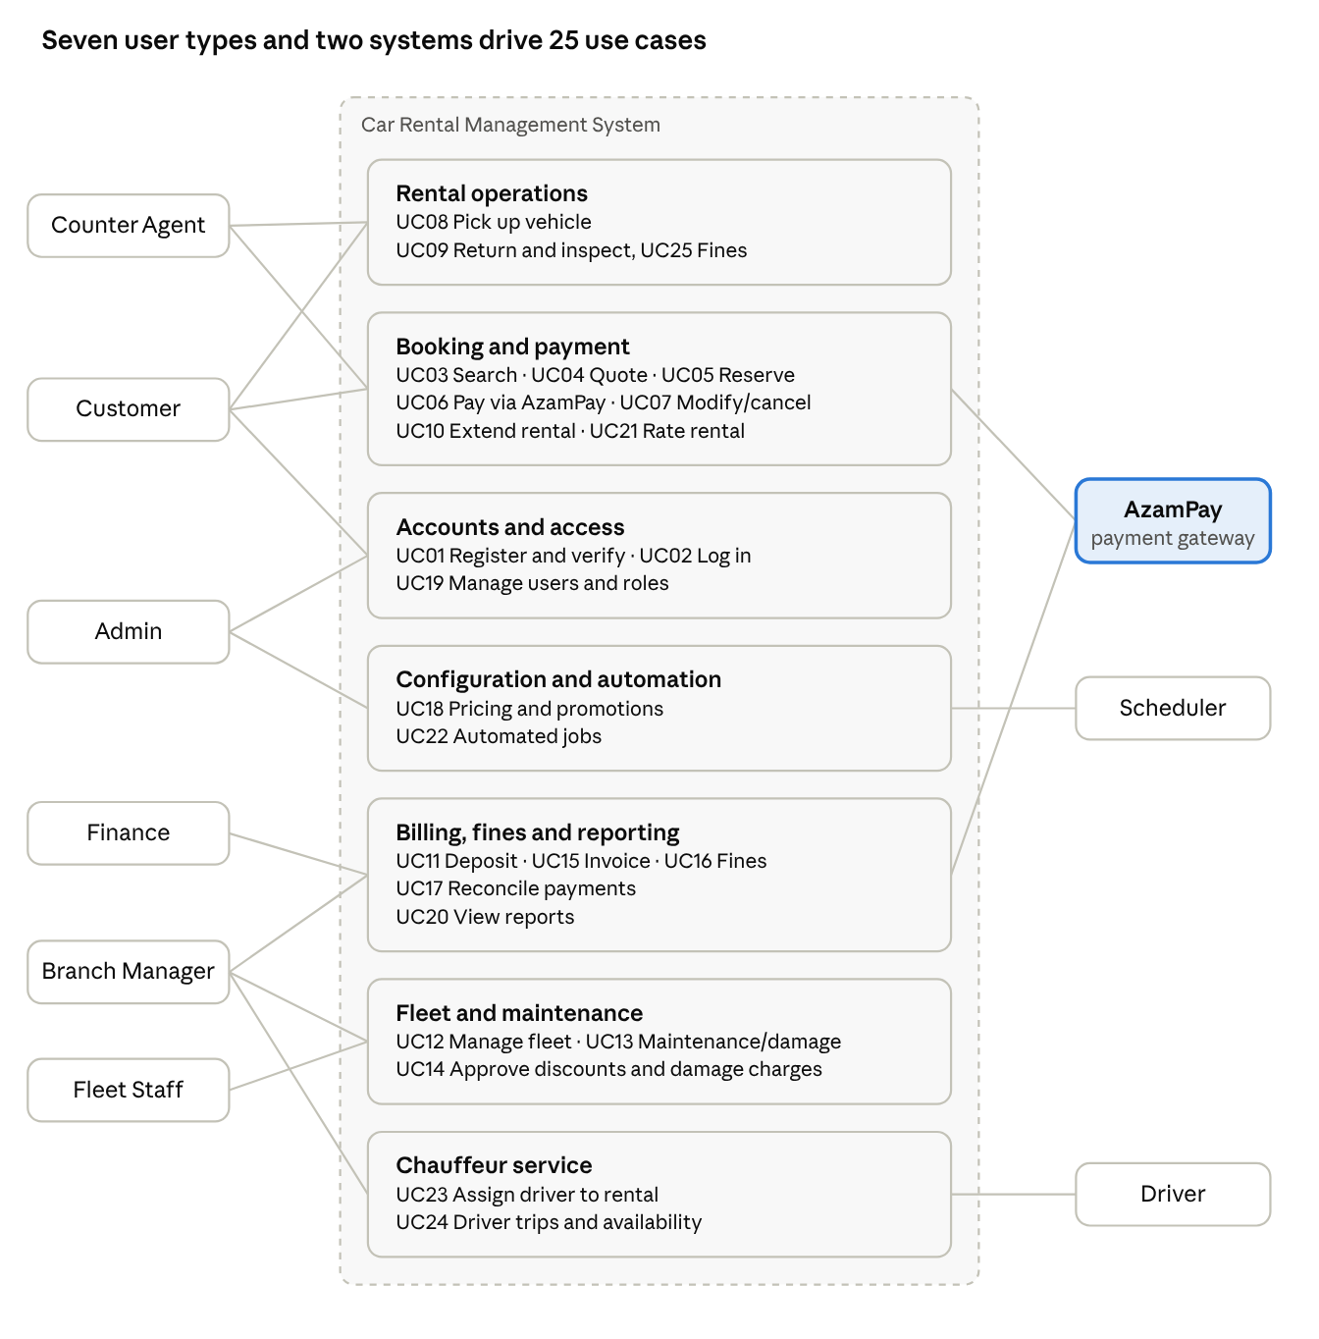
use case diagram · 6 user types, 2 systems, 22 use cases
Lines show which actor takes part in each group of use cases; UC numbers match the catalogue in 4.2.

4.2 Use case catalogue
ID | Use case | Actors | Summary
UC01 | Register and verify account | Customer, Agent | Create account, upload ID and license, agent or admin approves
UC02 | Log in / manage profile | All users | Authenticate, reset password, update details
UC03 | Search available vehicles | Customer, Agent | Query by branch, dates, category
UC04 | Calculate quote | Customer, Agent | Rate plan, extras, insurance, promo, tax, deposit
UC05 | Create reservation | Customer, Agent | Hold a vehicle or category for the period; the customer may request an office driver
UC06 | Pay via AzamPay | Customer, AzamPay | Customer approves mobile money or bank or card prompt; callback confirms
UC07 | Modify or cancel reservation | Customer, Agent | Change dates or cancel; refund per policy through AzamPay
UC08 | Pick up vehicle | Agent, Customer | Verify documents, assign vehicle, sign contract, record condition
UC09 | Return vehicle | Agent, Customer | Record mileage, fuel, inspection; review traffic fines and assign liability (UC25); compute fees
UC10 | Extend rental | Customer, Agent | Check availability, charge extra days
UC11 | Settle deposit | Finance, Agent, AzamPay | Deduct charges, refund the rest through AzamPay
UC12 | Manage fleet | Manager, Fleet | Add, edit, retire vehicles, change status
UC13 | Log maintenance and damage | Fleet | Service records, repairs, out-of-service flag
UC14 | Approve discounts and damage charges | Manager | Review and approve or reject
UC15 | Generate invoice | Finance, System | Itemized invoice per rental
UC16 | Record and bill fines | Finance | Link fine to rental; bill the customer only when liability is customer (UC25)
UC17 | Reconcile payments | Finance, AzamPay | Compare gateway transactions with the payments table
UC18 | Configure pricing and promotions | Admin | Rates, seasons, extras, insurance, promos
UC19 | Manage users and roles | Admin | CRUD users, assign roles
UC20 | View reports | Manager, Finance, Admin | Utilization, revenue, tax, overdue
UC21 | Rate rental | Customer | Rating and comment after return
UC22 | Run automated jobs | Scheduler | Expire holds, reminders, overdue flags, pending-payment checks
UC23 | Assign driver to rental | Manager, Agent | Pick an available driver for a chauffeured reservation; notify driver and customer
UC24 | Record driver trips and availability | Driver | Log daily start, end, odometer and incidents; set on-duty or off-duty
UC25 | Review fines and assign liability | Agent, Manager, Finance | At return inspection, list fines, decide customer or company liability, then bill or absorb

4.3 Detailed use case: UC06 Pay via AzamPay
Item | Description
Actors | Customer (primary), AzamPay (secondary)
Preconditions | Reservation exists with status pending; amount due is known
Main flow | 1. Customer chooses payment method (mobile money provider, bank or card) and enters phone or account. 2. System creates a payments row with status initiated and a unique external_id. 3. System requests AzamPay checkout with amount, currency, account and external_id. 4. AzamPay prompts the customer (for example a USSD push). 5. Customer approves with PIN on their own device. 6. AzamPay sends a callback with the result. 7. System verifies the callback, updates the payment to success, sets the reservation to confirmed and sends confirmation.
Alternate flows | A1: Customer rejects or times out, so the payment is failed and the reservation stays pending until the hold expires. A2: Callback is lost, so the scheduler queries AzamPay status and updates the payment. A3: Duplicate callback, ignored by idempotency check on gateway reference.
Postconditions | Payment recorded with gateway reference; reservation confirmed on success
Exceptions | Gateway unavailable (show retry, keep hold briefly); amount mismatch (mark review, alert Finance)

4.4 End-to-end customer routine
A rental runs through eleven stages from registration to rating, and every electronic payment in it goes through AzamPay.
- Register and verify (UC01). The customer creates an account and uploads ID and driving license. An agent or admin approves it; blacklisted customers are blocked.
- Search (UC03). The customer picks branch, dates, category and whether an office driver is wanted. The system checks vehicles and reservations for overlaps.
- Quote (UC04). The system adds extras, insurance, promo code, VAT, deposit and, for a chauffeured rental, the daily driver fee.
- Reserve (UC05). A reservations row is created as pending with a hold expiry. If a driver was requested, a driver_assignments row is created as requested.
- Pay via AzamPay (UC06). The customer approves a prompt on their phone. The verified callback sets the payment to success and the reservation to confirmed, and a receipt is sent. A decline or timeout lets the hold expire.
- Reminder and changes (UC07, UC22). The scheduler reminds the customer before pickup. Changes or cancellations recalculate the price and refund through AzamPay per policy.
- Pickup (UC08). The agent checks ID, license and payment, assigns the vehicle (and confirms the driver if one was requested), records odometer, fuel and photos, and the contract is signed. The rental becomes active.
- During the rental (UC10, UC24). The customer may extend and pay the extra days through AzamPay. Passing the return time makes the rental overdue and late fees start. For a chauffeured rental the driver logs daily trips and reports incidents.
- Return and inspection (UC09, UC25). The agent records end odometer, fuel and time, inspects the car for damage, and reviews every traffic fine received so far. Each fine gets a liability, customer or company (section 4.6).
- Billing and settlement (UC11, UC15). The invoice adds late, fuel, extra-km, damage, driver and customer-liable fine charges. Finance deducts them from the deposit and refunds the balance through AzamPay; any shortfall is paid through AzamPay. Fines that arrive after return (UC16) go through the same liability review.
- Close and feedback (UC21). The invoice becomes paid, the reservation completed, and the customer can rate the rental.

Sequence of messages
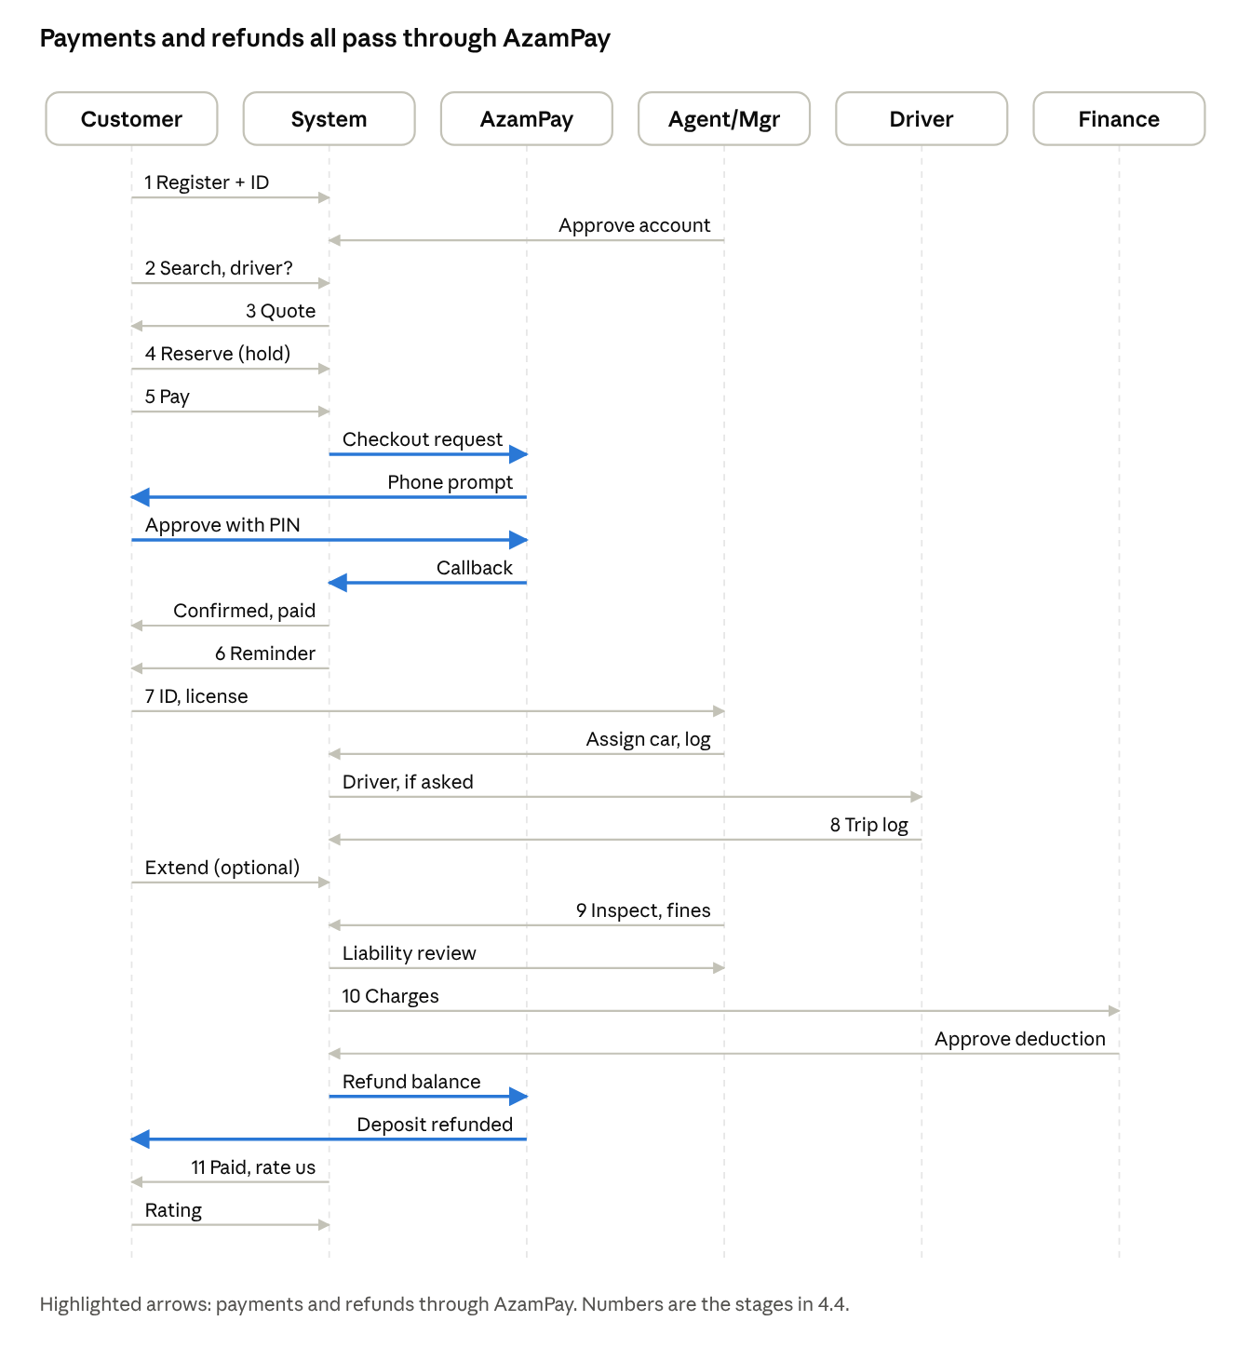
sequence diagram · 6 participants, 25 messages
Read top to bottom; stage numbers match the list above. The customer never pays the system directly: each payment and refund is a message to or from AzamPay.

Swimlanes
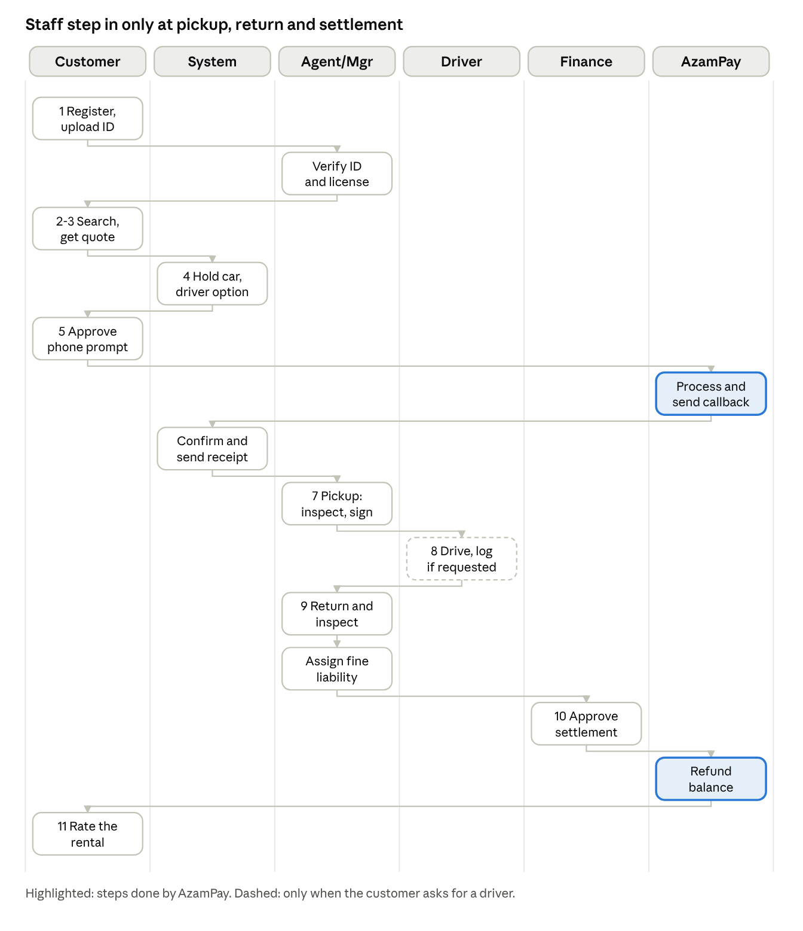
swimlane diagram · 6 lanes, 14 steps
The customer's own steps and the system's checks fill most of the flow; the agent acts at registration, pickup, return and fine liability, and Finance approves settlement.

4.5 Chauffeur (office driver) option
A customer can ask for an office driver when booking; the driver is a company employee assigned to the rental, so the customer does not drive.
- Fee: a per-day driver rate set by Admin is added to the quote and shown as a driver item on the invoice.
- Assignment: the Branch Manager or an agent picks an available driver from the roster (UC23). If none is free, the customer is offered self-drive or other dates.
- Pickup: the driver's name, license and phone are shown to the customer and written on the contract. Assumption: ID is still checked for the customer, but the customer's driving license is not required for a chauffeured rental.
- During the rental: the driver logs start, end and odometer for each day and reports incidents and fines (UC24).
- Fines: fines during a chauffeured rental are company-liable by default, because the company's driver was driving (section 4.6).

4.6 Traffic fines at return inspection
Every return inspection includes a traffic-fine check, and each fine is assigned to the customer or the company before anything is billed.
Cause | Examples | Liable | Result
Reckless or unlawful driving by the customer | Speeding, red light, illegal parking, toll evasion | Customer | Added to the invoice or deducted from the deposit
Vehicle issue the company should have fixed | Expired registration or inspection, faulty lights or plates, missing mandatory equipment | Company | Absorbed; logged against the vehicle with a reason; Fleet is notified
Chauffeured rental, driver's conduct | Driver speeding or illegal parking | Company by default | Absorbed; logged on the driver's record; the Branch Manager may reassign to the customer with a written reason (for example the customer insisted on the violation)
Cause unclear | No evidence either way | Branch Manager decides | Status under_review; not billed until decided
How the check works:
- The agent lists the fines found (authority notices, toll records, customer report) and records each against the rental with date, place, reference and photo or scan.
- The system compares the offence date and time with the rental period; a fine outside the period is never billed to the customer.
- The system also compares the offence date with the vehicle's document expiry dates (vehicle_documents); a fine that happened while registration, insurance or inspection had expired is flagged as company-liable.
- Fines that arrive after return follow the same review within the deposit hold period set by Admin.

5. Data Flow Diagrams
Notation: rectangles are external entities, circles or rounded boxes are processes, open rectangles are data stores (D1, D2...), arrows are data flows.

5.1 DFD Level 0 (Context diagram)
The whole CRMS is one process, "0 Car Rental Management System". External entities and main flows:
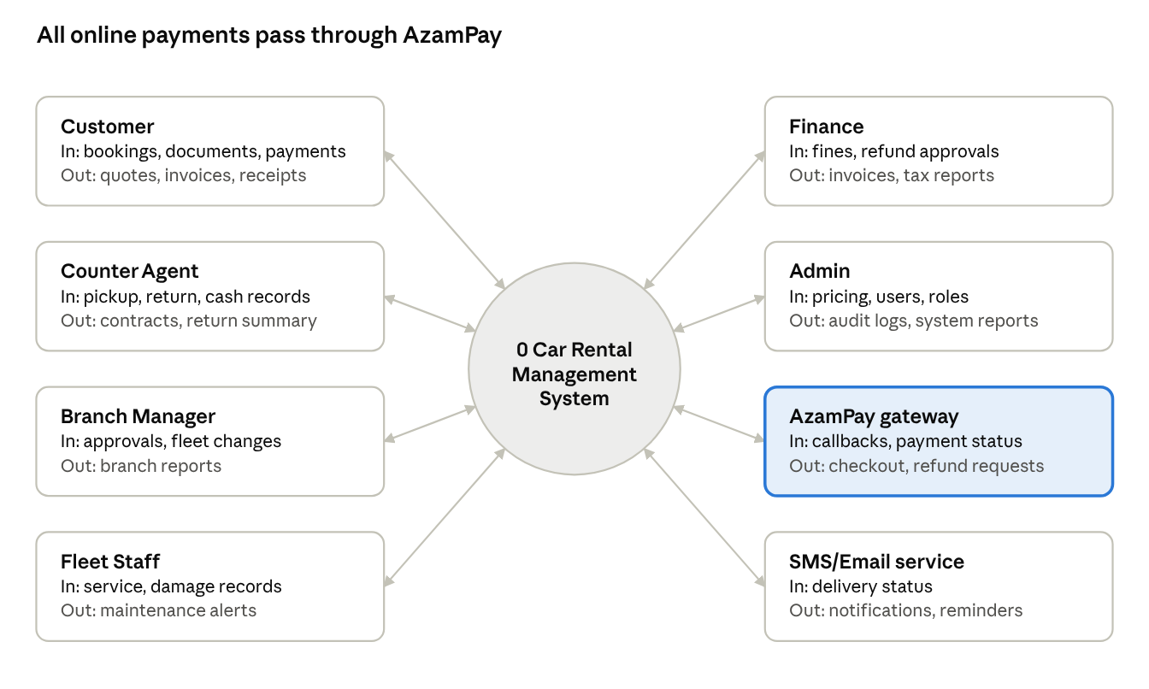
DFD level 0 · 1 process, 8 external entities
Data flows in both directions between every external entity and the system; the table lists them in detail.
Entity | Data in | Data out
Customer | Registration data, documents, search criteria, booking request, payment choice, ratings | Availability, quote, booking confirmation, invoices, receipts, notifications
Counter Agent | Walk-in data, pickup and return records, inspections, cash payment | Contract, reservation details, return summary
Branch Manager | Approvals, fleet changes | Branch reports, approval requests
Fleet Staff | Service and damage records | Maintenance alerts, vehicle status list
Finance | Fine entries, refund approvals | Invoices, reconciliation and tax reports
Admin | Pricing, users, roles, config | Audit logs, system reports
AzamPay | Payment callbacks, transaction status, refund results | Checkout requests, status queries, refund requests
SMS/Email Service | Delivery status | Notification messages

5.2 DFD Level 1
The system is decomposed into eight processes and the following data stores.
Data stores: D1 Users and Roles, D2 Customers, D3 Vehicles and Documents, D4 Rates, Extras, Promos, D5 Reservations, D6 Rentals and Inspections, D7 Invoices and Payments, D8 Fines, D9 Maintenance, D10 Reviews, D11 Audit Log.
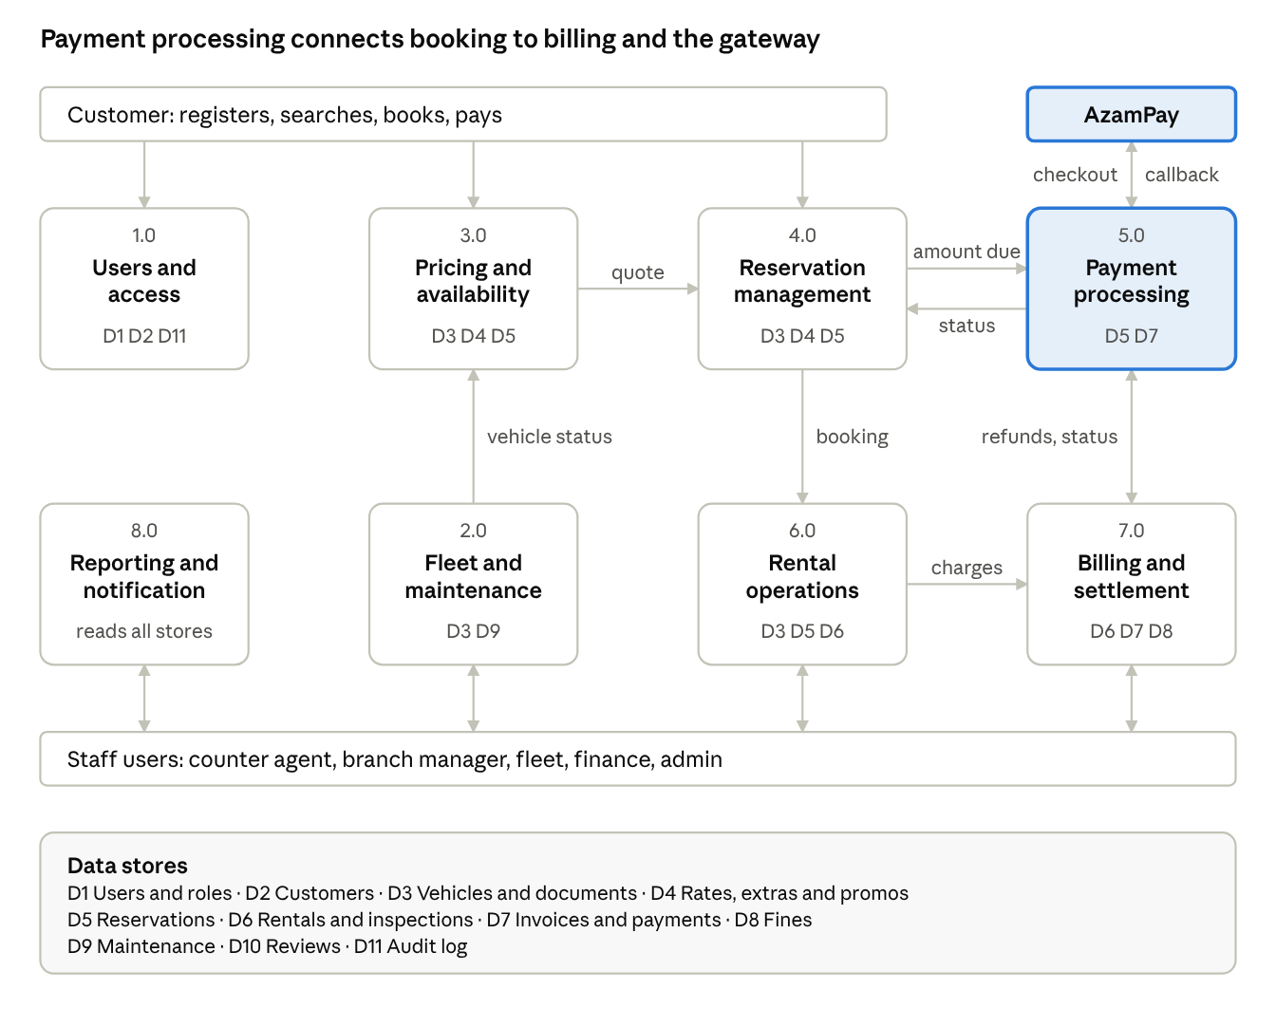
DFD level 1 · 8 processes, 11 data stores
Process 8.0 sends customer messages through the SMS/Email service on events from the other processes.
Process | Name | Inputs | Outputs | Stores
1.0 | User and access management | Registration, login, role changes | Session, verification status | D1, D2, D11
2.0 | Fleet and maintenance management | Vehicle data, service and damage records | Vehicle status, expiry alerts | D3, D9
3.0 | Pricing and availability | Search criteria, dates | Available vehicles, quote | D3, D4, D5 (read)
4.0 | Reservation management | Booking, modify, cancel | Reservation, hold, confirmation | D5, D3, D4
5.0 | Payment processing (AzamPay) | Amount due, payment method, gateway callbacks | Payment status, receipts | D7, D5
6.0 | Rental operations (pickup/return) | Documents, odometer, fuel, inspection | Contract, rental record, fees | D6, D3, D5
7.0 | Billing, fines and settlement | Rental data, fines, damage charges | Invoices, refunds, deposit release | D7, D8, D6
8.0 | Reporting and notification | Events, schedules | Reports, SMS and email messages | All (read), D11
Key flows between processes: 3.0 to 4.0 (selected vehicle and quote); 4.0 to 5.0 (amount due); 5.0 to 4.0 (payment success, reservation confirmed); 4.0 to 6.0 (confirmed reservation at pickup); 6.0 to 7.0 (final charges); 7.0 to 5.0 (refund and deposit release requests); 2.0 to 3.0 (vehicle status).

5.3 DFD Level 2: Process 5.0 Payment processing (AzamPay)
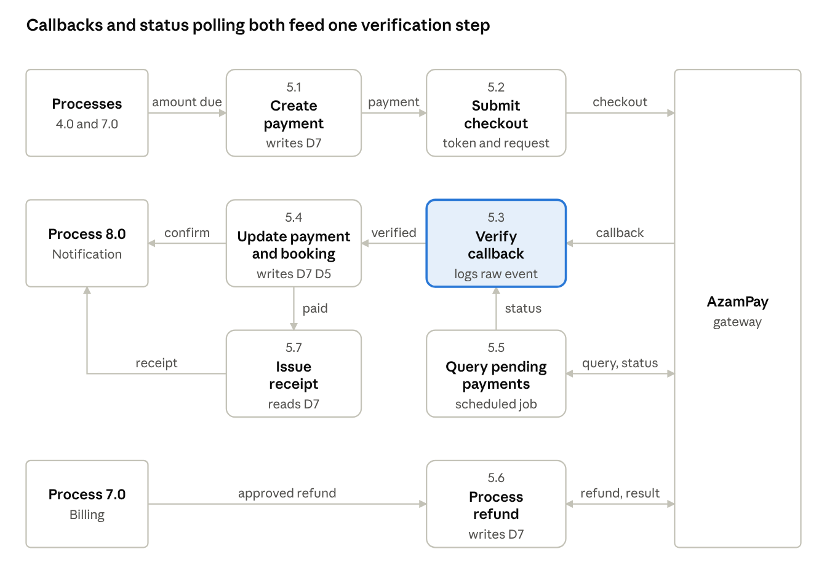
DFD level 2 · process 5.0, 7 sub-processes
The callback (5.3) and the scheduled status query (5.5) go through the same verification step, so a lost callback cannot leave a payment unresolved.
Sub-process | Description | Data flows
5.1 Create payment request | Validates amount, creates payment record with unique external_id | In: amount due from 4.0 or 7.0. Out: payment record to D7
5.2 Submit checkout to AzamPay | Obtains gateway token and sends checkout request | Out: checkout request to AzamPay. In: acknowledgement with gateway reference
5.3 Receive and verify callback | Validates callback authenticity, checks idempotency and amount | In: callback from AzamPay. Out: verified result; raw event to webhook log
5.4 Update payment and booking status | Sets payment to success or failed, confirms reservation | Out: status to D7, D5; confirmation request to 8.0
5.5 Query pending transactions | Scheduler polls AzamPay for payments without a callback | Out: status query to AzamPay. In: status. Out: update to 5.4
5.6 Process refund | Sends refund or disbursement request for approved amounts | In: approved refund from 7.0. Out: refund request to AzamPay; result to D7
5.7 Issue receipt | Builds receipt from successful payment | Out: receipt to Customer via 8.0

5.4 DFD Level 2: Process 6.0 Rental operations
Sub-process | Description | Data flows
6.1 Verify customer and booking | Checks ID, license validity, blacklist, payment status | In: reservation from D5, customer from D2
6.2 Assign vehicle | Picks an available vehicle in the category | In: vehicles from D3. Out: assignment
6.3 Record pickup condition | Odometer, fuel, photos, signed contract | Out: rental and inspection to D6; vehicle status to D3
6.4 Process return | Records end odometer, fuel, time; compares with pickup | In: rental from D6. Out: return record
6.5 Inspect and assess damage | Creates damage report and cost estimate | Out: damage report to D6, D9; approval request to Manager
6.6 Compute fees | Late, fuel, extra km, damage fees | Out: charges to 7.0
6.7 Review traffic fines | Lists fines found at return, compares offence date with the rental period and vehicle document expiry, assigns customer or company liability | In: fines from D8, documents from D3. Out: liability decision to D8; customer-liable amounts to 7.0
6.8 Assign driver and log trips | Picks an available driver for a chauffeured rental; the driver logs daily trips and incidents | In: driver roster, reservation. Out: assignment and trip logs to D6; driver fee to 7.0

5.5 DFD Level 2: Process 4.0 Reservation management
Sub-process | Description | Data flows
4.1 Check availability | Detects overlap on dates for category or vehicle | In: D5, D3
4.2 Calculate quote | Rates, extras, insurance, promo, tax, deposit | In: D4. Out: quote
4.3 Create hold | Saves reservation as pending with expiry time | Out: D5
4.4 Request payment | Sends amount to 5.0 | Out: amount due
4.5 Confirm reservation | On payment success sets confirmed | In: status from 5.0
4.6 Modify or cancel | Recalculates price, applies cancellation policy, requests refund | Out: refund request to 5.0

6. Entity Relationship Diagram

6.1 ERD
The ERD below shows entities, attributes and cardinalities.
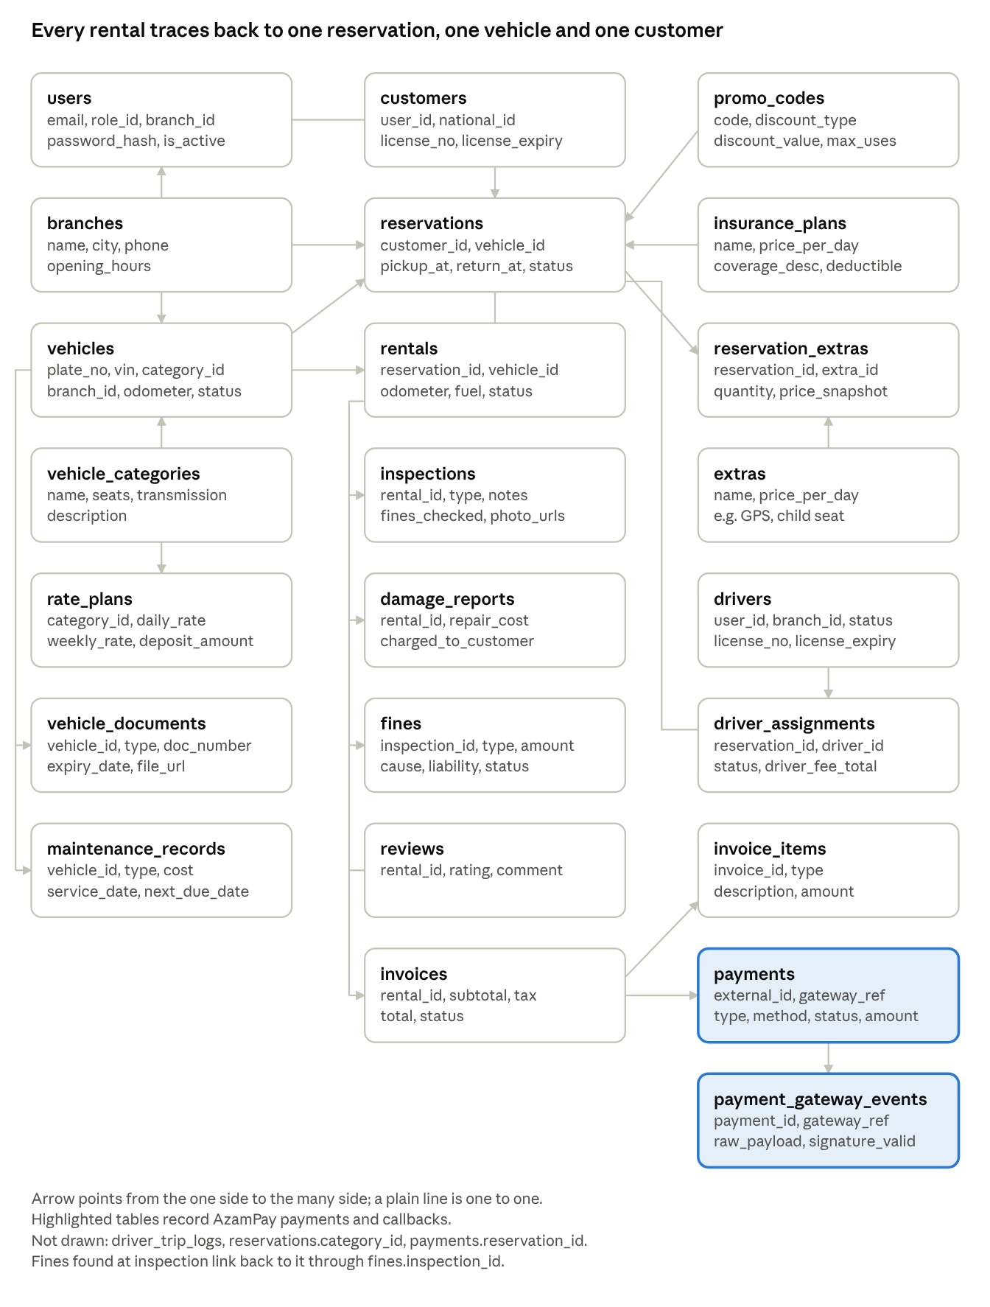
ERD · 22 entities with key attributes
Foreign keys follow the arrows; the full column list is in section 10. The roles table (users.role_id) is left out of the drawing for space.

6.2 Entity summary
Entity | Description
roles, users | Authentication and authorization; staff belong to a branch
customers | Customer profile and verification details linked to a user
branches | Rental locations
vehicle_categories, vehicles | Fleet and its classification
vehicle_documents | Insurance, registration, inspection with expiry dates
rate_plans, extras, insurance_plans, promo_codes | Pricing configuration
reservations, reservation_extras | Bookings and chosen add-ons
rentals, inspections, damage_reports | Actual rental and condition records
invoices, invoice_items | Billing
payments, payment_gateway_events | Payment records and raw gateway callbacks
fines | Traffic, toll and parking charges
maintenance_records | Service history
reviews, notifications, audit_logs | Feedback, messages, accountability
drivers | Office drivers with license details, branch and availability; linked to a user with the driver role
driver_assignments, driver_trip_logs | Driver assigned to a chauffeured reservation or rental, and the daily trip records

6.3 Cardinalities
- Branch 1:N Vehicles; Branch 1:N Staff users
- Category 1:N Vehicles; Category 1:N Rate Plans
- Customer 1:N Reservations; Reservation 1:0..1 Rental
- Reservation N:M Extras (via reservation_extras)
- Rental 1:N Inspections, Damage Reports, Fines, Invoices
- Invoice 1:N Invoice Items; Invoice 1:N Payments
- Payment 1:N Gateway Events
- Vehicle 1:N Documents, Maintenance Records

7. State Models
Reservation: pending, then confirmed (payment success), then completed; or pending to expired (hold timeout); confirmed to cancelled or no_show.
Payment: initiated, then pending (sent to AzamPay), then success or failed or expired; success to refunded or partially_refunded.
Vehicle: available, reserved, rented, maintenance, retired. Returned vehicles go to available after inspection and cleaning.
Rental: active, then returned; active to overdue when the return time passes; overdue to returned.
Driver assignment: requested, then assigned (manager picks a driver), then active (rental starts), then completed; requested goes to unassigned if no driver is free.
Fine: recorded, then under_review, then customer_liable (billed or deducted, then paid) or company_liable (absorbed).

8. Payment Integration Design (AzamPay)

8.1 Principles
- All electronic payments go through AzamPay. The CRMS keeps no sensitive payment credentials.
- Every payment has a unique external_id generated by the CRMS; the gateway returns its own reference (gateway_ref).
- Confirmation relies on the callback, backed by scheduled status queries.
- Callbacks are verified, logged raw and processed idempotently.
- API credentials (client ID, secret, token) are held in server-side secret storage, never in the client.

8.2 Payment flow (sequence)
- Customer selects pay in the web or mobile app.
- App calls the CRMS backend; backend creates payments (status initiated).
- Backend authenticates to AzamPay and submits the checkout request.
- AzamPay acknowledges; payment becomes pending.
- Customer receives a prompt on their phone and approves.
- AzamPay calls the CRMS callback URL with the outcome.
- Backend verifies, stores the event in payment_gateway_events, updates payments and the reservation, and notifies the customer.
- The app polls the backend (or receives a push) to show the final result.

8.3 Deposits and refunds
- A security deposit is collected as a payment of type deposit and is not part of the invoice total.
- On return, Finance computes deductions (damage, fines, late fees). The balance is refunded to the customer's mobile money or bank account through AzamPay, recorded as deposit_release.
- Cancellation refunds follow the configured policy (for example full refund more than 48 hours before pickup).
- Fines found at return inspection: only customer-liable fines are deducted from the deposit or invoiced. Company-liable fines are absorbed and never reach the customer. A fine under review is held back until the Branch Manager decides.

8.4 Failure handling
Case | Handling
Customer declines or times out | Payment failed; allow retry; hold expires after the configured window
Callback never arrives | Scheduler queries AzamPay and reconciles
Duplicate callback | Ignored using unique gateway_ref
Amount mismatch | Payment flagged review; Finance alerted
Gateway down | Show friendly error; keep hold briefly; allow agent cash payment as fallback
Refund fails | Retry; escalate to Finance after the limit

8.5 Reconciliation
Finance uses a daily reconciliation view that compares AzamPay's transaction report with the payments table. Differences (missing, extra or mismatched amounts) are listed for investigation.

9. Non-Functional Requirements
- Security: HTTPS, hashed passwords, role-based access control, callback signature or token verification, IP allow-listing where supported, audit logging.
- Availability: target 99.5%; payment callback endpoint must be highly available.
- Performance: search results under 2 seconds; booking transaction under 3 seconds excluding gateway time.
- Integrity: exclusion constraint against double booking; all money amounts stored as integers or decimals, never floats.
- Auditability: all price overrides, refunds and status changes are logged.
- Usability: mobile-first customer interface, Swahili and English.
- Privacy: protect ID and license data; restrict access by role.

10. Database Schema (PostgreSQL)
Primary keys are id unless stated. Money columns use NUMERIC(12,2). All tables include created_at.

10.1 Access and people
roles(id PK, name UNIQUE)
users(id PK, role_id FK, branch_id FK NULL, email UNIQUE, password_hash,
full_name, phone, is_active, created_at)
customers(id PK, user_id FK UNIQUE, dob, address, national_id,
license_number, license_country, license_expiry,
verification_status, blacklisted BOOL)
branches(id PK, name, address, city, phone, opening_hours)

10.2 Fleet
vehicle_categories(id PK, name, seats, transmission, description)
vehicles(id PK, category_id FK, branch_id FK, plate_no UNIQUE, vin UNIQUE,
make, model, year, color, fuel_type, odometer,
status) -- available/reserved/rented/maintenance/retired
vehicle_documents(id PK, vehicle_id FK, type, doc_number, expiry_date, file_url)
maintenance_records(id PK, vehicle_id FK, type, description, cost, vendor,
service_date, next_due_date, next_due_odometer)

10.3 Pricing
rate_plans(id PK, category_id FK, daily_rate, weekly_rate, km_limit_per_day,
extra_km_fee, deposit_amount, valid_from, valid_to)
extras(id PK, name, price_per_day)
insurance_plans(id PK, name, price_per_day, coverage_desc, deductible)
promo_codes(id PK, code UNIQUE, discount_type, discount_value,
valid_from, valid_to, max_uses, used_count)

10.4 Booking and rental
reservations(id PK, customer_id FK, vehicle_id FK NULL, category_id FK,
pickup_branch_id FK, return_branch_id FK, pickup_at, return_at,
insurance_plan_id FK NULL, promo_id FK NULL,
daily_rate_snapshot, total_estimated, deposit_amount, with_driver BOOL, driver_fee_snapshot NULL,
status, -- pending/confirmed/cancelled/no_show/expired/completed
hold_expires_at, created_by FK users, created_at)
reservation_extras(reservation_id FK, extra_id FK, quantity, price_snapshot,
PK(reservation_id, extra_id))
rentals(id PK, reservation_id FK UNIQUE, vehicle_id FK, agent_pickup_id FK,
agent_return_id FK NULL, actual_pickup_at, actual_return_at NULL,
start_odometer, end_odometer, start_fuel, end_fuel,
status) -- active/returned/overdue
inspections(id PK, rental_id FK, type, notes, photo_urls, fines_checked BOOL, inspected_by FK, inspected_at)
damage_reports(id PK, rental_id FK, vehicle_id FK, description, repair_cost,
charged_to_customer BOOL, approved_by FK NULL, photo_urls)
fines(id PK, rental_id FK, inspection_id FK NULL, type, amount, offence_at, reference_no, status, cause, liability, liability_reason, decided_by FK users NULL, billed BOOL)

10.5 Billing and payments (AzamPay)
invoices(id PK, rental_id FK, issued_at, subtotal, tax, total,
status) -- draft/issued/paid/void
invoice_items(id PK, invoice_id FK, type, description, amount)
payments(id PK, external_id UNIQUE, -- generated by CRMS, sent to AzamPay
invoice_id FK NULL, reservation_id FK NULL, customer_id FK,
type, -- payment/deposit/refund/deposit_release
method, -- mobile_money/bank/card/cash
provider, -- e.g. Azampesa, Airtel, Tigo, Halopesa, CRDB, NMB
account_ref, -- phone or account (masked in views)
amount, currency DEFAULT 'TZS',
status, -- initiated/pending/success/failed/expired/review/refunded
gateway_ref UNIQUE NULL, -- AzamPay transaction reference
failure_reason NULL, requested_at, completed_at NULL,
recorded_by FK users NULL) -- set only for cash
payment_gateway_events(id PK, payment_id FK NULL, gateway_ref,
event_type, raw_payload JSONB, signature_valid BOOL,
processed BOOL, received_at)
reconciliation_runs(id PK, run_date, gateway_total, system_total,
mismatches JSONB, run_by FK users)

10.6 Support tables
reviews(id PK, rental_id FK UNIQUE, rating, comment, created_at)
notifications(id PK, user_id FK, channel, subject, body, status, sent_at)
audit_logs(id PK, user_id FK, action, entity, entity_id, details JSONB, created_at)

10.7 Constraints and indexes
- Exclusion constraint on reservations using gist over (vehicle_id, tstzrange(pickup_at, return_at)) for active statuses to prevent double booking.
- Indexes: payments(external_id), payments(gateway_ref), reservations(customer_id, status), vehicles(branch_id, status), vehicle_documents(expiry_date).
- Check constraints: return_at > pickup_at, amount > 0, rating BETWEEN 1 AND 5.
- Prices are copied onto reservations and invoices at booking time so later rate changes do not alter existing bookings.
- Assign the specific vehicle at pickup when booking by category.

10.8 Chauffeur service and fine liability
New tables for the office driver option:
drivers(id PK, user_id FK UNIQUE, branch_id FK, license_number, license_class,
license_expiry, daily_rate NULL,
status) -- available/assigned/off_duty/inactive
driver_assignments(id PK, reservation_id FK UNIQUE, rental_id FK NULL, driver_id FK NULL,
pickup_at, return_at, driver_fee_total,
status, -- requested/assigned/active/completed/unassigned
assigned_by FK users NULL, assigned_at NULL)
driver_trip_logs(id PK, assignment_id FK, trip_date, start_at, end_at,
start_odometer, end_odometer, notes, incident BOOL)
Values for the changed fines table:
- cause: customer_reckless, vehicle_defect, driver_conduct, unclear
- liability: customer, company, pending
- status: recorded, under_review, billed, absorbed, paid
- A fine with liability = company is never billed; liability_reason and decided_by are required when liability is set.
Other rules:
- Add the role driver to roles, and the invoice item type driver to invoice_items.
- Copy pickup_at and return_at onto driver_assignments and add an exclusion constraint on (driver_id, tstzrange(pickup_at, return_at)) so a driver cannot be double-booked.

11. Reports
- Fleet utilization per branch and category
- Revenue by period, branch, category and payment method
- Overdue and upcoming returns
- Outstanding fines and unpaid invoices
- Maintenance and document expiry
- Payment reconciliation (AzamPay versus system)
- VAT summary

12. Suggested Technology and Deployment
- Frontend: responsive web app and mobile app (customer), web (staff)
- Backend: REST API with background job runner for scheduler tasks
- Database: PostgreSQL
- Integrations: AzamPay (payments), SMS and email provider
- Hosting: cloud server with HTTPS, public callback URL for AzamPay, daily backups

